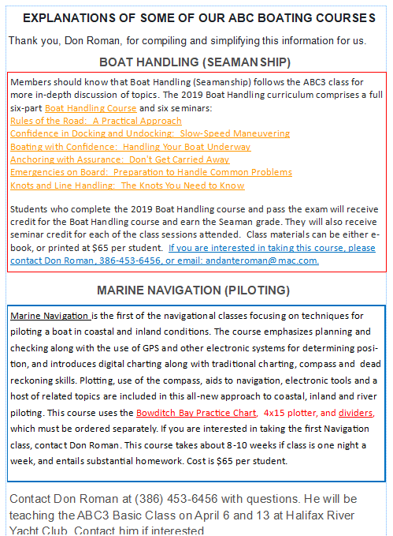
Our next boating safety class will be held on 2 Saturdays, April 6 and April 13, at Halifax River Yacht Club. This is the class that all boaters born after 1988 must have to legally pilot a boat in Florida. Contact our Assistant Safety Education Officer, Don Roman, for more information at (386) 453-6456 or email andanteroman@mac.com.

