Daytona Beach Sail & Power Squadron

What: BOATING SAFETY CLASS - a two day class

When: Two Saturdays, 13 & 20 May’23 from 0900 - 3:30pm.

Where: Halifax River Yacht Club, 331 South Beach Street, Daytona Beach, 32114

This is the Two-Day course you need to get your Safe Boater Education ID required of anyone born on, or after, 1 January 1988 to operate a power boat in Florida. An excellent introduction to Boating, Boat Handling, Navigation Rules of the Road, Aides to Navigation, Florida Boating laws and regulations, Boating Safety, and more. Experienced, or new, skipper, or crew; this course is for you. This course is FUN.
Cost: $39.50 payable by cash, check or credit. Couples can share materials with a 50% discount at $59.00. Credit cards incur a 3.5% transaction fee. Costs cover textbooks.

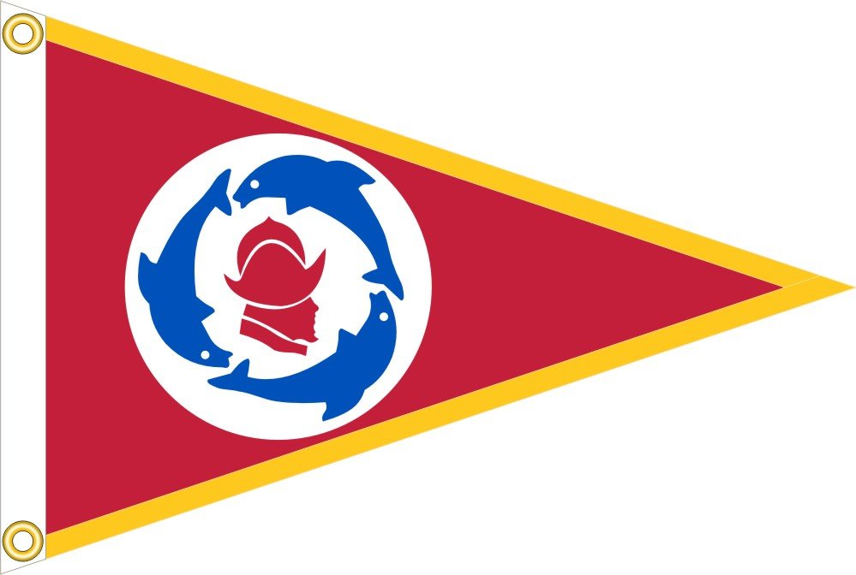
Email: abcdaytonabeach@gmail.com, or call: Don Roman, 386-453-6456, or visit: https://www.abcdb.club for more information. Email or call for your reservation.

Take a course - be more knowledgeable - be a better boater.
Safe Passages in 2023!
